*M. Fuat Kına*

***Final Report: The Effect of Land Occupations in Brazilian Rural on the Bolsa Familia Social Assistance Programme, and the Spillover Effect***

There has been a productive discussion on Brazilian emerging welfare system, that have significantly enhanced in terms of both the increase in the share of social expenditures over GDP and the expansion of the coverage of policies with decreasing income inequality in the whole country including both urban and rural (Hall, 2006; Huber & Stephens, 2012; Zucco, 2013; Lustig, Lopez-Calva & Ortiz-Juarez, 2016). Bolsa Familia (BF) has been introduced as a flagship welfare program in Brazil during early 2000s. It is one of the largest social assistance programmes in the world, covering quarter of the Brazilian population (World Bank, 2015).

There are numbers of studies published on the impacts of BF in recent years (Teixeira, 2010; Soares, Ribas & Osorio, 2010; Rasella, Aquino, Santos, Paes-Sousa & Barreto, 2013; Cotta & Machado, 2013; Bither-Terry, 2014; Guanais, 2015; De Brauw, Gilligan, Hoddinott & Roy, 2015). However, its determinants have not been attention-grabbing as well. By focusing on the causes of BF, this paper carries out an examination that whether the social assistances are used as a political containment strategy by the Brazilian governments.

What is more, as a response of land dispossession experienced in Brazil during the second half of the 20th century, Brazilian rural has also faced expropriating land occupations since 1980s which were organized by radical social and political movements. The association of welfare expansion in Brazil with the rural conflicts deserves consideration in depth. The land occupations have been discussed in terms of its capacity to affect politics overall (Carter, 2010), improve participatory democracy (Wolford, 2010) and social equity (Keck, 1995). They are widely known with their integrative character that they are mostly organized by Landless Workers Movement (MST), which is a leftist movement and received a great deal of the Catholic Church.

This paper focuses on the question that what is the relationship between land occupations in rural and nationwide social assistances. It aims to uncover this association and comprehend on the intended target of those policies, and hence follows the question of “discretion”, by investigating the effect of rural militancy on BF.

Since there might be a spatial correlation problem, I developed a geographical neighborhood dataset to see the effect of land occupations in the borderline neighboring municipalities. As it can be seen in Figure 1, the distribution of land occupations has a significant intensity in the south and east regions of Brazil. The major aim in this study is to handle with a possible spatial bias with this geographical concentration, to control for it, and to see the spillover effect itself, I created a new independent variable by utilizing geographical data.

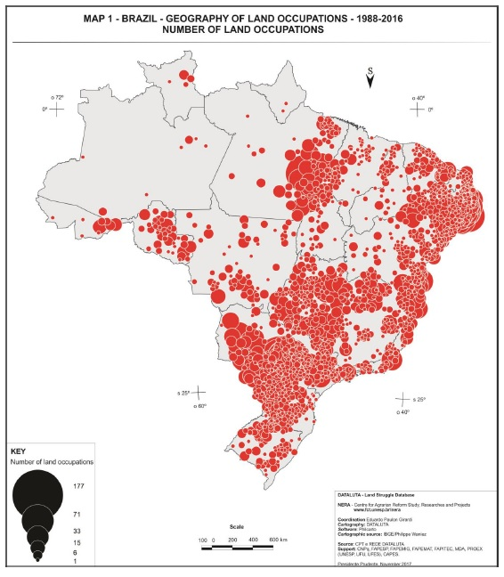

Figure : Land occupation concentration in Brazilian municipalities. Source: DATALUTA

Therefore, my two hypotheses are these:

* Hypothesis 1: The land occupations have significant impact on the distribution of social assistances in Brazil.
* Hypothesis 2: The land occupations in neighboring municipalities are positively associated with the land occupation of that municipality, and after controlling for it, first hypothesis is still valid.

**Dataset**

In order to construct the dataset, I collected each variable separately, from various sources. An official website of Brazilian government[1] presented most of control variables like GDP, Human Development Index, homicide, population, tax revenues of federal government from that municipality, agricultural expenditures. Social assistance variables are also gathered by these official sources. I will use the total expenditure over population as dependent variable. Land occupations for each municipality and year are reported by a non-governmental institution, CPT Nacional[2]. I extracted and combined them all by excel formulas. Since there is not much land occupations in one year in a municipality, mostly single occupation is observed, I prefered the dummy version for my major independent variable.

Scholars focusing on political determinants mostly consider electoral results (Fried, 2012). That’s why I also added the votes of incumbent party (PT) as a control variable. In the social policy literature, there is also another control variable, state-capacity, which refers the ability of a government to administer its territory effectively (Skocpol, 1985). For many cases, it is hard to find a direct information of state-capacity. However, scholars mostly utilized proxies like government’s security budgets, road lengths or else. Although these proxies are not available for Brazilian case, there is again an institution[3] that grades institutional performance of government in each municipality for different fields (Bersch, Praça & Taylor, 2013). At the end, I have a municipal level, yearly based dataset (with 5,500 municipalities and 5 years from 2005-2009).

For the borderline neighborhood dataset, I used ArcGIS. It outputted an excel file with neighborhood matchings. In the raw dataset, there were approximately 33000 rows, which means almost six neighbors for each municipality. Without considering the length of the borderlines I basically calculate for each municipality that how many neighboring municipalities that targeted one has, with land occupation. Then transformed it to a dummy variable since again the similar small variation problem.

**Model specification**

As aforementioned, there has been massive literature on both structural and political impacts of BF. Due to a wide expectation that BF affects political opposition, my model would control for a reverse causality. First strategy to handle with this endogeneity problem, I use first- and second-years lags for my independent variables. A second, but more significant strategy made in this study is utilizing the instrumental variable approach.

The main challenge within instrumental variable analysis is to find a valid instrument, which should be uncorrelated with the error term of the second stage (main) equation. There were too many factors affecting land occupations, but all of them arouse suspicion to be related to BF, through poverty. Then I decided to validate my instrument by historical origins of the land occupations and put a time range between instrument and BF that might help to eliminate the risk of correlation. I found a data for private lands in 1995 (in terms of hectar units).

However, that was time invariant, I had time variant independent variables, and there seemed a fixed effect in the data. Therefore, in addition to fixed effect panel data analysis and random effect instrumental variable analysis, I carry out five cross sectional instrumental variable analyses. I will present only their results. To see the first stage results and to be sure that the private land is a valid instrument, I used “ivreg2” command in Stata.

For spillover effect, I added previously constructed dummy variable to the final my model. Before that, I checked for the relationship between land occupations in the targeted and neighboring municipalities as a first stage. There should be positive relationship to claim for a spillover effect. What is more, I also checked for the coefficient of spillover variable to understand its unique effect.

Then, my first model stands for the spillover effect itself. The second model utilizes instrumental variable without controlling the spillover, and the third one does the same with it. All models are cross-sectional.

**Findings**

Figure 2 presents a first stage result for the spillover effect. It gives the effect of land occupations in the neighbors on the land occupations in the targeted municipality. There is a positive relationship as I expect. All coefficients (from 2005 to 2009) consistently imply geographical concentration as in Figure 1. If there is any land occupation in a municipality, then one could expect to find any at neighboring municipalities.

Figure 2: Model 1



The results of instrumental variable cross-sectional analyses, before and after adding spillover effect are shown at Figure 3. The magnitudes and the signs are not much changed, but error terms seemingly increased. Therefore, a consistent negative effect of land occupations on BF seems robust. It implies a punishment mechanism. If there is a land occupation in a municipality, then the government would be more likely to give less social assistances.

Figure 3: Model 2 and Model 3



According to Figure 4, so interestingly, the effect of spillover appears positive, which could mean that the government gives more assistance to the municipalities which are exposed to the land occupation potentiality through their neighboring municipalities. This means that observing any thread of land occupation, government used assistances as a preventive tool to contain the potential opposition in the targeted municipality.

Figure 4: Model 3, the coefficients of the spillover effect



For the instrumental variable analyses (Model 2 and Model 3), all models are passed from the tests of under-identification, weak-identification and over-identification, and the instrument (private lands in 1995) strongly predicts land occupations.

**Conclusion**

In the light of the findings, I argue that the central government has a political memory on the land occupations. Findings bring us a politicized allocation of benefits. On the one hand, the BF has been used as a punishment for rural militancy, for which I observed a negative effect of land occupations, even controlling for the spillover effect. On the other hand, a spillover threat is observed by the government, there seems a positive effect, which could mean that social assistances are also used as a preventive political containment strategy. Hence, the analyses in this project reveal a two-fold political strategy carried out through BF.

The BF social assistance programme deserved and attracted the very much attention in the literature. It is the same for the land occupations in the rural of Brazil. However, the relationship between these two is invisible. This paper offered to think that hopeful shift in the Brazilian social policy as one of positive outcomes of the countrywide land occupations. Furthermore, scholars should think on a room for political factors in determination of social policies in addition to the structural characteristics. Not only electoral politics, but also contentious politics could lead governments to cover more and more people through these social assistance programmes.

**References:**

Bither-Terry, R. (2014). Reducing poverty intensity: What alternative poverty measures reveal about the impact of Brazil's Bolsa Família. *Latin American Politics and Society*, *56*(4), 143-158.

Carter, M. (2010). The landless rural workers movement and democracy in Brazil. *Latin American Research Review*, 186-217.

Cotta, R. M., & Machado, J. C. (2013). The Bolsa Familia cash transfer program and food and nutrition security in Brazil: a critical review of the literature. *Revista panamericana de salud publica= Pan American journal of public health*, *33*(1), 54-60.

De Brauw, A., Gilligan, D. O., Hoddinott, J., & Roy, S. (2015). The impact of Bolsa Familia on schooling. *World Development*, *70*, 303-316.

Fried, B. J. (2012). Distributive politics and conditional cash transfers: The case of Brazil’s Bolsa Família. *World Development*, *40*(5), 1042-1053.

Guanais, F. C. (2015). The combined effects of the expansion of primary health care and conditional cash transfers on infant mortality in Brazil, 1998–2010. *American Journal of Public Health*, *105*(S4), S593-S599.

Hall, A. (2006). From Fome Zero to Bolsa Família: social policies and poverty alleviation under Lula. *Journal of Latin American Studies*, *38*(4), 689-709.

Huber, E. and J. D. Stephens (2012) Democracy and the Left: Social Policy and Inequality in Latin America, University of Chicago Press.

Keck, M. E. (1995). Social equity and environmental politics in Brazil: lessons from the rubber tappers of Acre. *Comparative Politics*, 409-424.

Lustig, N., Lopez-Calva, L. F., Ortiz-Juarez, E., & Monga, C. (2016). Deconstructing the decline in inequality in Latin America. In *Inequality and growth: Patterns and policy* (pp. 212-247). Palgrave Macmillan, London.

Rasella, D., Aquino, R., Santos, C. A., Paes-Sousa, R., & Barreto, M. L. (2013). Effect of a conditional cash transfer programme on childhood mortality: a nationwide analysis of Brazilian municipalities. *The lancet*, *382*(9886), 57-64.

Skocpol, T. (1985). "Bringing the State Back In: Strategies of Analysis in Current Research." In *Bringing the State Back In,* ed. Peter B. Evans, Dietrich Rueschemeyer, and Theda Skocpol, 3–37. Cambridge: Cambridge University Press.

Teixeira, C. G. (2010). *A heterogeneity analysis of the Bolsa Familia Programme effect on men and women's work supply*(No. 61). Working Paper, International Policy Centre for Inclusive Growth.

Wolford, W. (2010). Participatory democracy by default: Land reform, social movements and the state in Brazil. *The Journal of Peasant Studies*, *37*(1), 91-109.

Zucco Jr, C. (2013). When payouts pay off: Conditional cash transfers and voting behavior in Brazil 2002–10. *American journal of political science*, *57*(4), 810-822.

1. <http://ipeadata.gov.br/Default.aspx>
2. <https://www.cptnacional.org.br/>
3. <http://www.firjan.org.br/>